Instruction
Pay attention：
1.you just need to unzip the  ，get and
don't unzip the “update .zip”file

- Copy the directly to the SD/U disk root directory

Upgrade method1： Upgrade at boot
1. Preparing for upgrade, power off the machine, after the upgrade file is unzipped (suffix. Img) copy to the u disk, or sdcard (if
Use sdcard must insert GPS card slot). Insert the storage device (U disk or sdcard) with the upgrade file into the machine
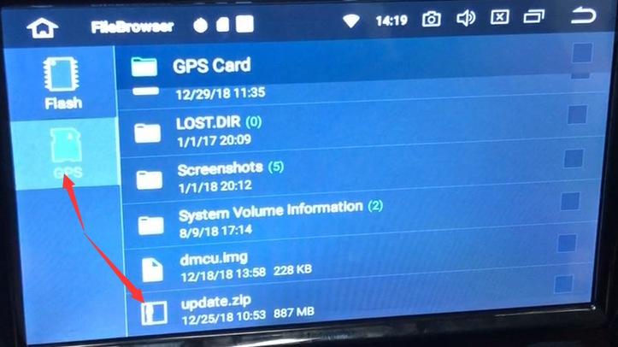

2.Select the desktop settings icon, click Settings, enter the Settings interface.
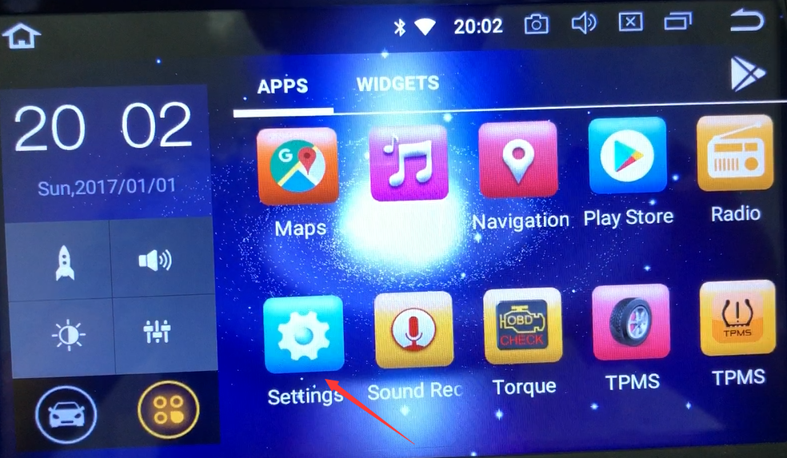
3.Choose system
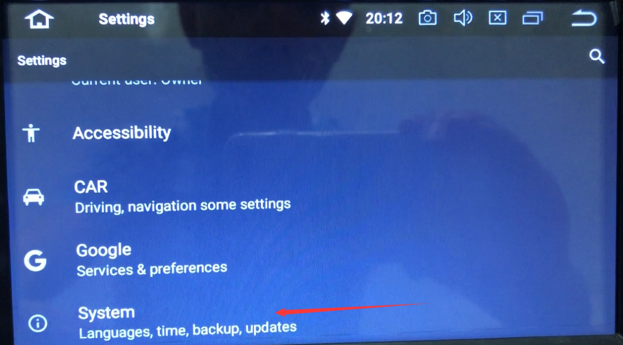
4.choose system update
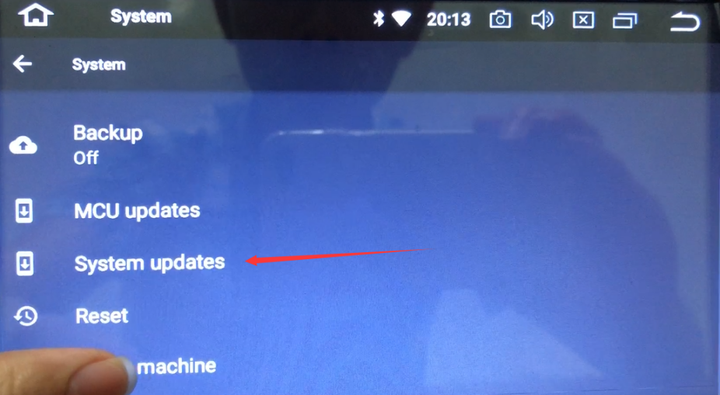
5.Click on the system update, pop-up upgrade dialog box
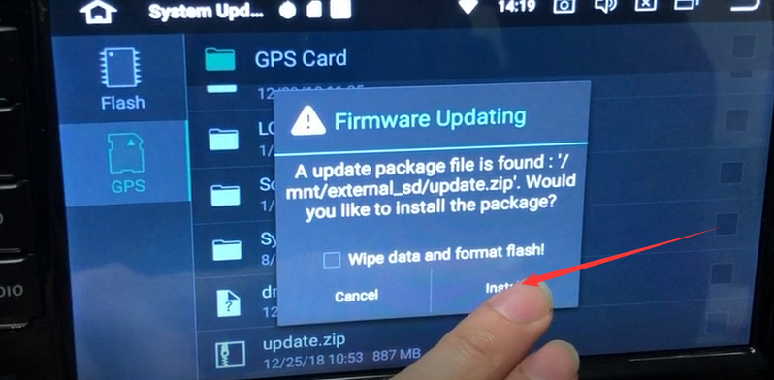

- Click Install, the machine automatically restart, enter the upgrade interface, the system automatically start the upgrade
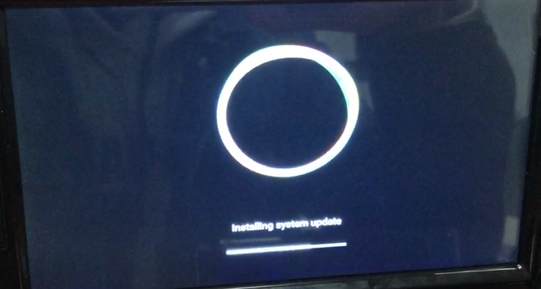

7.progress bar run, the machine automatically restart, upgrade is complete. (The first reboot time 2-3 minutes after upgrade belongs to the normal situation)
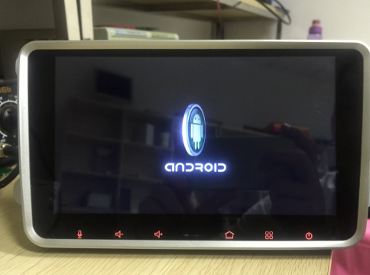

Up to now three kinds of upgrade methods are introduced.
Note: The entire upgrade process can not disconnect the electricity, otherwise it will
Cause the machine can not start.

Upgrade method 2: full touch machine upgrade method
1. Preparing for upgrade, power off the machine, after the upgrade file is unzipped (suffix. Img) copy to the u disk, or sdcard (if
Use sdcard must insert GPS card slot). Insert the storage device (U disk or sdcard) with the upgrade file into the machine
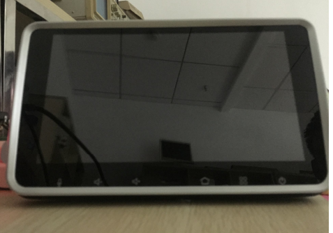

2. Press and hold the REST button without releasing it, then power it on again and wait for 5 seconds before releasing it.
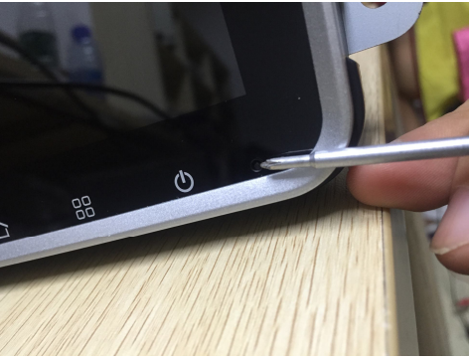

3.Wait about 30 seconds to enter the upgrade
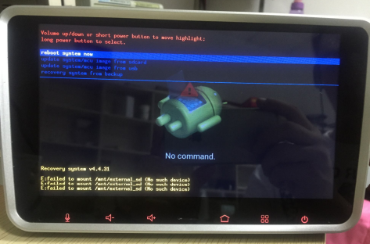

4.Short press the reset button, select the next Updata system / mcu from sdcard (when the upgrade file in the GPS card slot to select the item)
Updata system / mcu from usb (when the upgrade file in usb choose this)

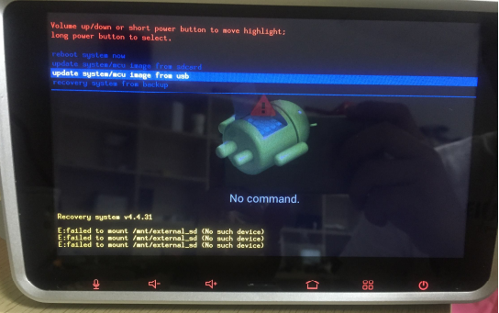

5.After the selected press and hold the reset button, the system starts to upgrade

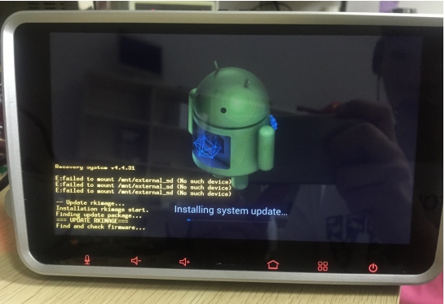

- .upgrade progress bar finished, the upgrade is complete, the machine restarts. (Upgrade the first reboot time of 2-3 minutes is normal)

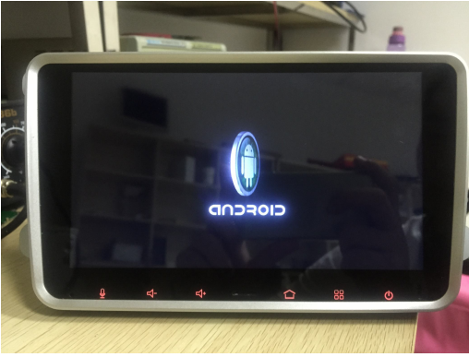

Upgrade method3：With button machine upgrade method

1.Prepare for upgrade, power off the machine, copy the upgrade file (suffix for .img) to USB flash drive, or sdcard (if
The sdcard must be inserted in the GPS card slot). Insert the storage device (U disk or sdcard) with the upgrade file into the machine
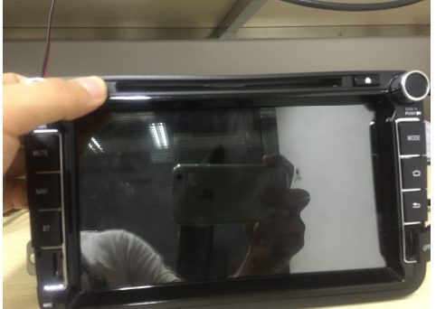

- Long press the power button does not release and then power. After 5 seconds release the button
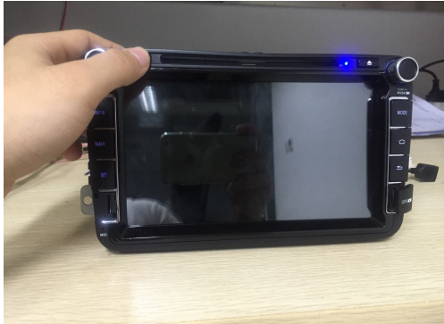

3..Wait about 30 seconds to enter the upgrade
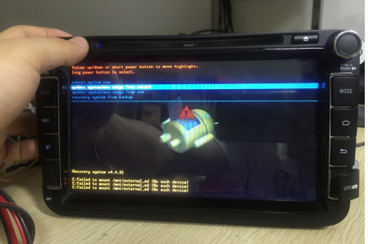

4.Short press the power button, select the next item
Updata system / mcu from sdcard (when the upgrade file in the GPS card slot to select the item)
Updata system / mcu from usb (when the upgrade file in usb select this
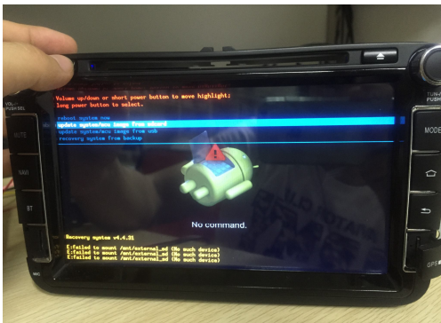

- After the long press the power button to start
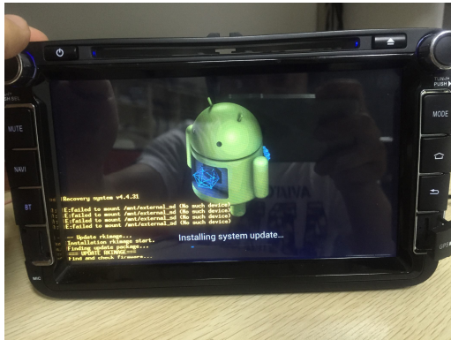

6.upgrade progress bar finished, the upgrade is complete, the machine restarts. (Upgrade the first reboot time of 2-3 minutes is normal)
